INDIAN INSTITUTE OF TECHNOLOGY

KHARAGPUR

APPLIED COMPUTATIONAL METHODS LABORATORY

LAB – 6 Report

Rajiv Harlalka

20MA20073

Department of Mathematics

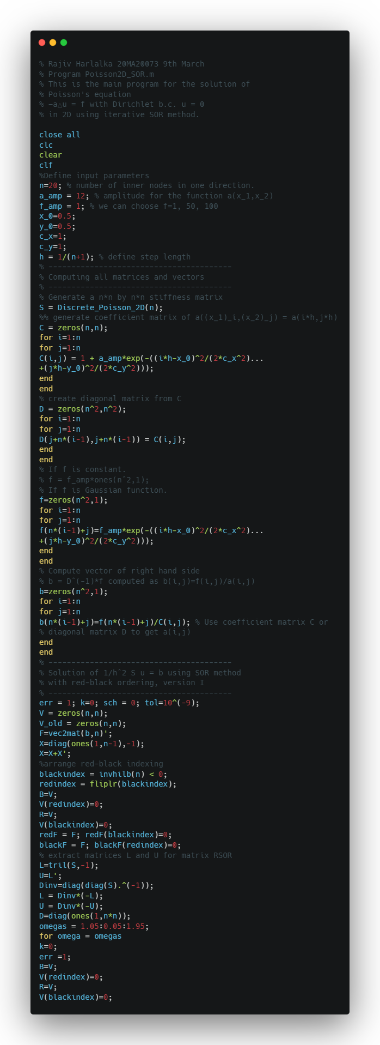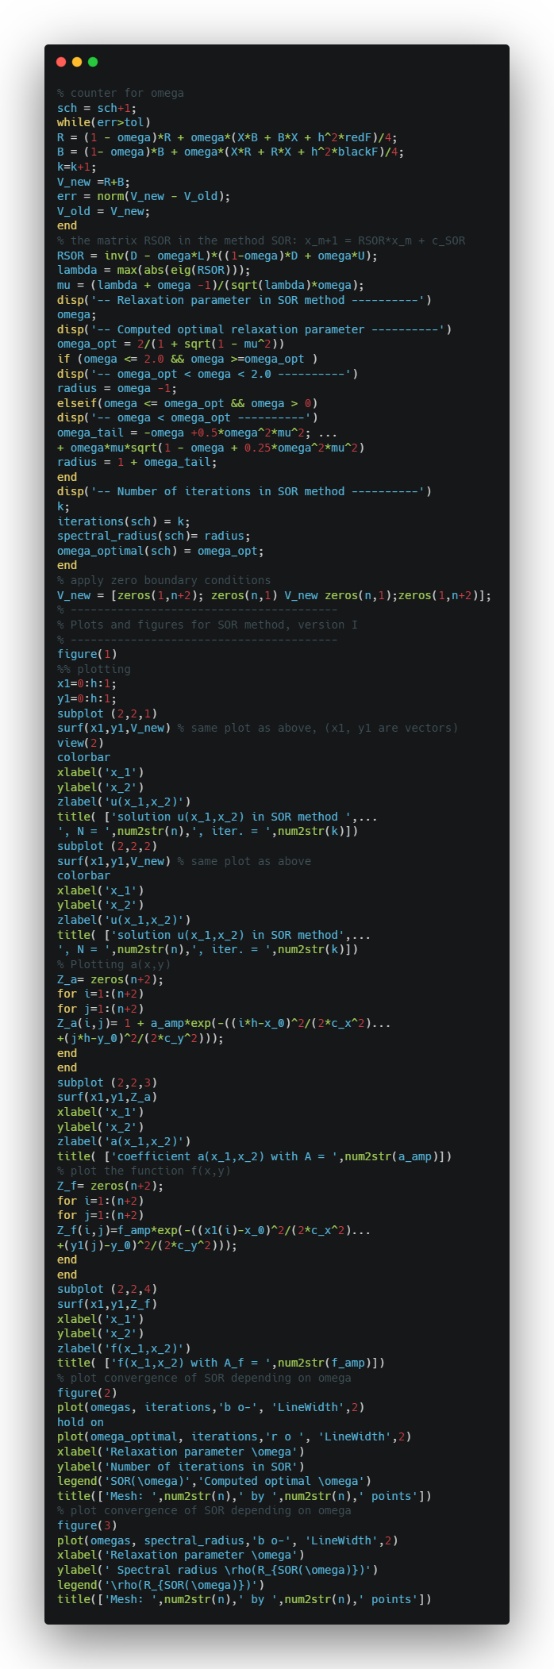

Output:

-- Relaxation parameter in SOR method ----------

-- Computed optimal relaxation parameter ----------

omega_opt =

1.7406

-- omega < omega_opt ----------

ans =

0.4864

-- Number of iterations in SOR method ----------

-- Relaxation parameter in SOR method ----------

-- Computed optimal relaxation parameter ----------

omega_opt =

1.7406

-- omega < omega_opt ----------

ans =

0.4813

-- Number of iterations in SOR method ----------

-- Relaxation parameter in SOR method ----------

-- Computed optimal relaxation parameter ----------

omega_opt =

1.7406

-- omega < omega_opt ----------

ans =

0.4734

-- Number of iterations in SOR method ----------

-- Relaxation parameter in SOR method ----------

-- Computed optimal relaxation parameter ----------

omega_opt =

1.7406

-- omega < omega_opt ----------

ans =

0.4626

-- Number of iterations in SOR method ----------

-- Relaxation parameter in SOR method ----------

-- Computed optimal relaxation parameter ----------

omega_opt =

1.7406

-- omega < omega_opt ----------

ans =

0.4490

-- Number of iterations in SOR method ----------

-- Relaxation parameter in SOR method ----------

-- Computed optimal relaxation parameter ----------

omega_opt =

1.7406

-- omega < omega_opt ----------

ans =

0.4323

-- Number of iterations in SOR method ----------

-- Relaxation parameter in SOR method ----------

-- Computed optimal relaxation parameter ----------

omega_opt =

1.7406

-- omega < omega_opt ----------

ans =

0.4125

-- Number of iterations in SOR method ----------

-- Relaxation parameter in SOR method ----------

-- Computed optimal relaxation parameter ----------

omega_opt =

1.7406

-- omega < omega_opt ----------

ans =

0.3894

-- Number of iterations in SOR method ----------

-- Relaxation parameter in SOR method ----------

-- Computed optimal relaxation parameter ----------

omega_opt =

1.7406

-- omega < omega_opt ----------

ans =

0.3626

-- Number of iterations in SOR method ----------

-- Relaxation parameter in SOR method ----------

-- Computed optimal relaxation parameter ----------

omega_opt =

1.7406

-- omega < omega_opt ----------

ans =

0.3317

-- Number of iterations in SOR method ----------

-- Relaxation parameter in SOR method ----------

-- Computed optimal relaxation parameter ----------

omega_opt =

1.7406

-- omega < omega_opt ----------

ans =

0.2959

-- Number of iterations in SOR method ----------

-- Relaxation parameter in SOR method ----------

-- Computed optimal relaxation parameter ----------

omega_opt =

1.7406

-- omega < omega_opt ----------

ans =

0.2540

-- Number of iterations in SOR method ----------

-- Relaxation parameter in SOR method ----------

-- Computed optimal relaxation parameter ----------

omega_opt =

1.7406

-- omega < omega_opt ----------

ans =

0.2032

-- Number of iterations in SOR method ----------

-- Relaxation parameter in SOR method ----------

-- Computed optimal relaxation parameter ----------

omega_opt =

1.7406

-- omega < omega_opt ----------

ans =

0.1350

-- Number of iterations in SOR method ----------

-- Relaxation parameter in SOR method ----------

-- Computed optimal relaxation parameter ----------

omega_opt =

1.7500

-- omega_opt < omega < 2.0 ----------

-- Number of iterations in SOR method ----------

-- Relaxation parameter in SOR method ----------

-- Computed optimal relaxation parameter ----------

omega_opt =

1.8000

-- omega_opt < omega < 2.0 ----------

-- Number of iterations in SOR method ----------

-- Relaxation parameter in SOR method ----------

-- Computed optimal relaxation parameter ----------

omega_opt =

1.8500

-- omega_opt < omega < 2.0 ----------

-- Number of iterations in SOR method ----------

-- Relaxation parameter in SOR method ----------

-- Computed optimal relaxation parameter ----------

omega_opt =

1.9000

-- omega_opt < omega < 2.0 ----------

-- Number of iterations in SOR method ----------

-- Relaxation parameter in SOR method ----------

-- Computed optimal relaxation parameter ----------

omega_opt =

1.9500

-- omega_opt < omega < 2.0 ----------

-- Number of iterations in SOR method ----------

Plot SOR Solution

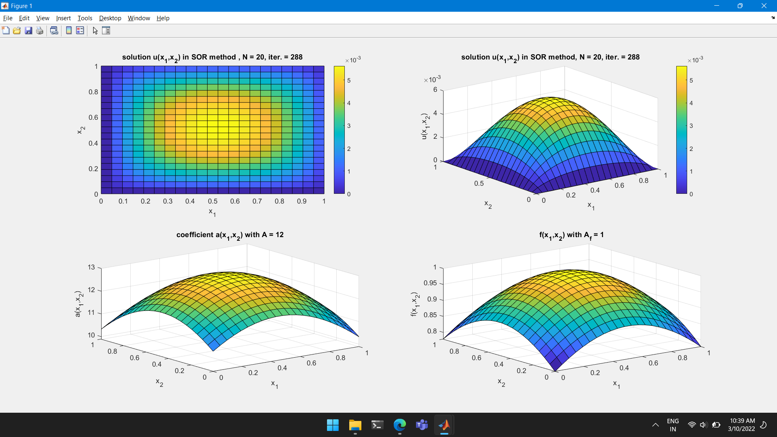

Plot SOR Iterations and Spectral Radius

